Serious Games

Serious Game for helping with C++ Coding Language Revision Documentation (Design/Implementation/Evaluation)

B00329641 B00273962 B00350757

UWS Lanarkshire

Contents

1 Design 4

1.1 Learning Outcomes 4

1.2 Introduction 4

1.3 Justification 4

1.4 Examples of Serious Games regarding Coding: 5

1.4.1 RoboCode 5

1.4.2 CodingGame 6

1.4.3 Code Combat 6

1.5 Team Roles 7

1.5.1 Roles 7

1.5.2 Document Segments Written 7

1.6 Game Design 8

1.6.1 Narrative 8

1.6.2 Lessons/Quests 8

1.7 Intended Game Quiz Questions (Assessment Integration) 9

1.7.1 Introduction (cout) 9

1.7.2 Basic Functions 9

1.7.3 Loops 9

1.7.4 Function Arguments 10

1.7.5 Final Test 11

1.8 UML Designs 13

1.8.1 Intended Player Path 13

1.8.2 Main Menu Designs 13

1.8.3 Top Down Design 14

2 Implementation 15

2.1 Game Overview 15

2.1.1 Narrative Changes from Design Segment 15

2.1.2 Narrative Overview 15

2.2 Software Specifications 15

2.2.1 Software 15

2.3 Controls 16

2.3.1 Player Movement 16

2.3.2 Multiple Choice 16

2.4 Game Progression Breakdown 16

2.5 Content Integration 17

2.6 Code/Scripts 18

2.6.1 Main Menu Scripts 18

2.6.2 Options Scripts 22

2.7 Functionality 24

2.7.1 Main Menu 24

2.7.2 Main Game 25

2.8 Showreel (Screenshots) 27

2.8.1 Main Menu 27

2.8.2 Introduction Slides 29

2.8.3 Main Game 30

2.8.4 Credits 33

2.9 Dialogue System 34

2.9.1 Book Shelf Dialogue Tree 34

2.9.2 Robot Dialogue Tree 34

2.9.3 Garage Door 35

2.9.4 Grade 35

2.9.5 Introduction Dialogue 36

2.9.6 Dialogue Database Variables 36

2.9.7 Quest List 36

2.9.8 Quest Layout 37

2.10 Video Walkthrough 38

2.11 Version Control 38

3 Evaluation 39

3.1 Evaluation Methodology 39

3.2 Experimental Design 39

3.3 Questionnaire Template 40

3.3.1 Design of Questionnaire 40

3.3.2 Implementation of Questionnaire 41

3.4 Identification of Participants 43

3.5 Feedback Analysis 44

3.6 Weaknesses of Evaluation 44

# Design

## Learning Outcomes

For our game, we hope to meet the learning outcomes, regarding the learning aspect:

1. Knowledge of Coding Syntax – coding syntax refers to the rules that specify the correct combined sequence of symbols to form a correctly structured program via the specified coding language.
2. Understanding of Coding Efficiency – the ability to characterize and describe how reliability, speed and programming methodology can help with developing codes for an application.
3. Application of Code Reusability – being able to choose/demonstrate that similar code can be used for different forms of functionality.
4. Analysis of Code – to analyze and categorize different forms of coding.
5. Creating Problem Solving Methodology – to be able to construct and organize an efficient batch of code to work correctly for a specified problem.

## Introduction

Evolving steadily over the past two decades, serious games have become rapidly developed for a wide range of applications, including but not limited to;

* Resource games such as World Without Oil (2007), which took place over thirty-two days in April to June. Players would make decisions in a world decimated by an oil crisis and how it affected their area.
* Coping with medical conditions in Superbetter (2012), which was developed after Jane McGonigal suffered a concussion and created the prototype while recovering. The app uses gamified elements to help people achieve goals and overcome obstacles.

While games are usually regarded as entertainment sources, these games are designed for an educational purpose instead. Often regarded as entertaining tools, they are a pool of knowledge for the player to utilize and learn from in a fun, challenging way through the use of a score, accolade or advancements. The main way for the players to learn is through a subconscious acquisition.

## Justification

The next generation of coding professionals are most likely either familiar with a computer or are enjoying the many complex and rich games available on the market currently. If the educational system were to use the cognitive ability required to play these games, and mask education with the same graphics these students are witnessing right now, it could help vastly with production efforts nation-wide.

## Examples of Serious Games regarding Coding:

### RoboCode

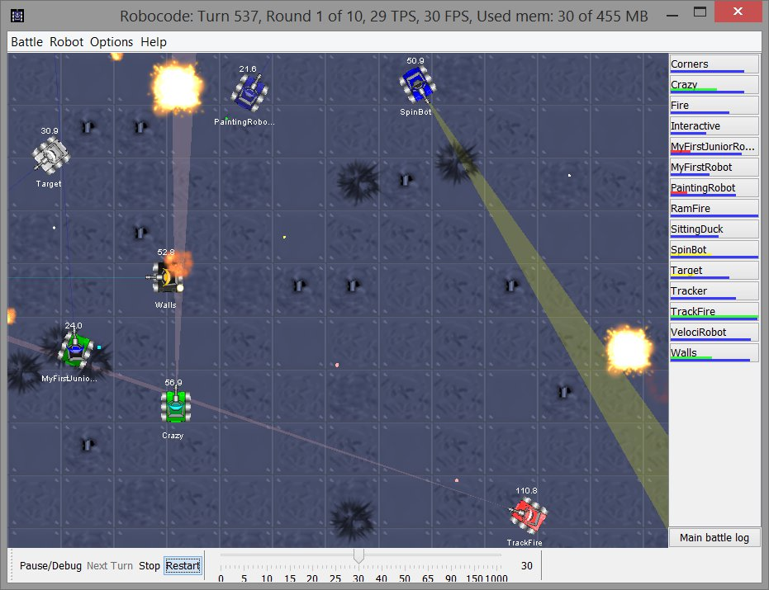

Figure This is a Programming gamer that has the objective of defeating other robots in a battle arena. To accomplish this goal the player must write the AI of the robot telling it how to behave under different Events. This was to teach the Java programming language in a fun way.

### CodingGame

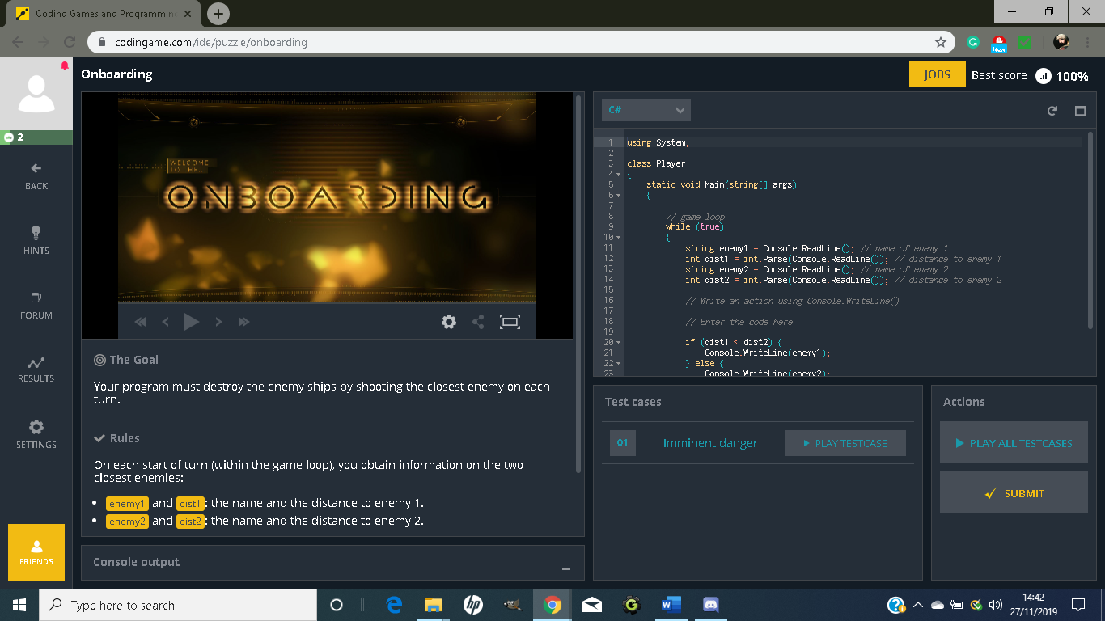

Figure - This is a website with several games that pose a pure coding challenge to learn new concepts in a fun competitive way. Each game has different goals and the system is set up to teach multiple languages.

### Code Combat

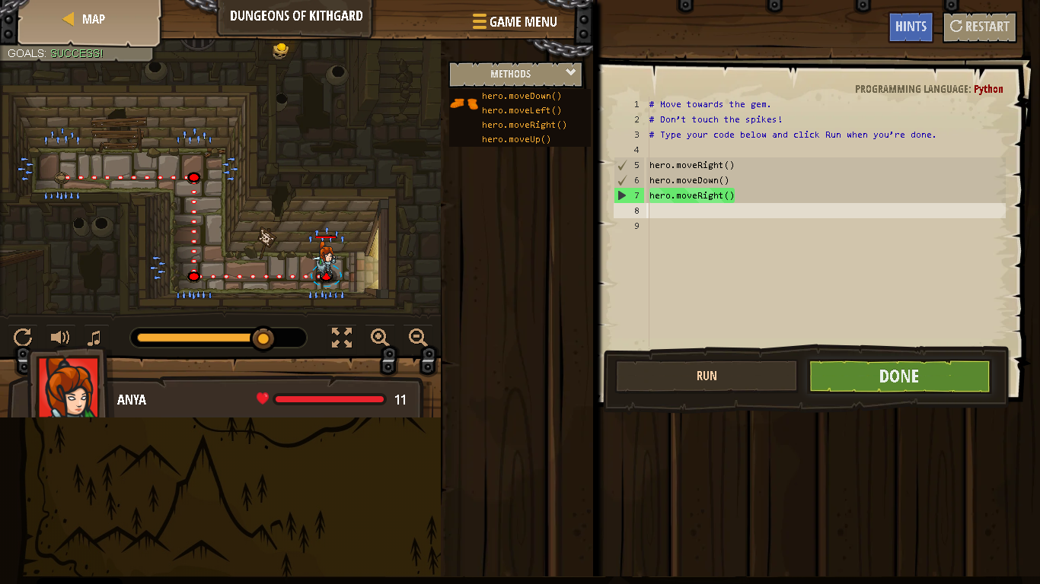

Figure - This game is to teach the basic concepts of Python it is styled like an RPG and is popular in schools the player gathers equipment and gold they must avoid traps and monsters all movement is handled in the coding section.

## Team Roles

### Roles

|  |  |  |
| --- | --- | --- |
| Team Name | Banner No. | Roles |
| Matthew Mungall | B00329641 | Project Manager/Lead Designer/Coder |
| Scott McKay | B00273962 | Assistant Designer |
| Leo Masnada | B00350757 | Assistant Coder |

### Document Segments Written

|  |  |  |
| --- | --- | --- |
| Team Name | Banner No. | Segment Written |
| Matthew Mungall | B00329641 | Implementation |
| Scott McKay | B00273962 | Design |
| Leo Masnada | B00350757 | Implementation |

## Game Design

### Narrative

Our game is centered around the coding of a robot, using quizzes found on a terminal to transfer functionality into said robot. The player will take control of a young coder, John, as he works through the terminal to fully program his robot. By completing various quizzes and inputting lines of code, the robot will learn and evolve to allow for new functionality (such as speaking, dancing and moving). Once the player has finished all of the quizzes and fully interacted with the robot, they will be able to leave the garage to finish the game.

### Lessons/Quests

Note: the first/last quests have no learning on the player’s end and are used to bookend the serious game.

|  |  |  |  |  |
| --- | --- | --- | --- | --- |
| Quest | Objective | No. of Questions asked | Result | Expected Learning Outcome Reached |
| **Quest 1: “HE110_W0R1D”** | Learn about how cout works and how it can be used for displaying messages | One | Player learns the importance of console logging in regard to programming. | 1. Knowledge of Coding Syntax |
| **Quest 2: “Basic Function”** | Learn about function calling | Two | Player learns function calling | 1. Understanding of Coding Efficiency |
| **Quest 3: “Looper”** | Learn about loops and implement them into the robot’s functionality | Three | Player learns about for and while loops, what the functions of each are and what ones are illegitimate. | 1. Application of Code Reusability |
| **Quest 4: “Three Argument”** | Details different function arguments and how the player can use them. | Four | Player learns arguments in functions and code readability. | 1. Analysis of Code |
| **Quest 5: "Final Test"** | Tests player’s knowledge from previous quests. | Five | Robot is fully functional & completes the game | 1. Creating Problem Solving Methodology |

## Intended Game Quiz Questions (Assessment Integration)

**\*Answers in bold indicate right answer**

*\*Answers in italic indicate incorrect answers*

By utilizing a multiple choice-based system, users will answer questions relating to C++ programming. Below, there are 15 questions relating to many topics.

### Introduction (cout)

Q1. What will the following code will display what outcome?

|  |
| --- |
| #include <iostream>  using namespace std;  int main()  {  cout << "Hello, World!";  return 0;  } |

1. *main()*
2. *Hello World 0*
3. **Hello World**
4. *iostream*

### Basic Functions

Q1. Given the function description above about arrays, how would you send in the console the Wednesday value?

1. *cout(days[2]);*
2. **cout << days[2];**
3. *cout << days(2);*
4. *cout << days.2;*

Q2. Given three values, test that A and B are equals and C is lower than A and B with one expression:

1. *(A = B) > C*
2. *(A == B) >> C*
3. *A = B > C*
4. **(A == B) > C**

### Loops

Q1. Which of these loops is NOT a recognized loop in the C++ coding language?

1. **then loop**
2. *for..next loops*
3. *while loops*
4. *do loops*
5. *int i=0; do{"i=10"i endl;}*

Q2. Given the following code: for(int i = 0; i <= 10; i++){code();} How many times will this loop execute the code ?

1. 9
2. **11**
3. 10
4. Compile error

Q3. Given the following code: int i=0; do{cout << "i= " << i <<endl;}while(i < 10); What will the last line of the console print?

1. 9
2. 10
3. **0**
4. Error

### Function Arguments

Q1. A function that needs to use variables that can be different at each iteration has passed arguments, it is written on the format:

1. **type name(argumentType argumentName){code;}**
2. *type name{code;}(argumentType argumentName);*
3. *name(argumentName);*
4. *name type(argumentName argumentType){code;}*

Q2. When you use a function that needs arguments, you need to pass it:

1. *the same name of variables only*
2. *the same type and name of variables*
3. *anything as long as the spot is filled*
4. **the same type of variable only**

Q3. Using a function that has overrides can work as long as:

1. **You pass it any of the argument groups one override supports**
2. *You pass it all the arguments it asks in the different overrides*
3. *You pass it one argument that is not in the other overrides*
4. *You pass it any of the values the overrides support*

Q4. In case you are not sure your program provides one of the arguments you need, you can give the function a default value, you should then:

1. *Remove the arguments you can give a default value to and make a variable in your code instead*
2. *Never give default values*
3. *Give all your arguments a default value*
4. **Give only the necessary arguments a default value**

### Final Test

Q1. When it comes to printing out a string, which line would be best suited?

1. *string boot = Hello world !;*
2. *string = "hello world !";*
3. *boot string = "Hello world !";*
4. **string boot = "Hello world !";**

Q2. When it comes to calling a function, which method would be appropriate for the robot to walk?

1. *walk;*
2. **walk();**
3. *int walk();*
4. *walk()*

Q3. For the robot to move, we must utilize loops. How would we use the loop to summarize the code? (no repeated function calling)

1. *for (int i = 0; i++, i <= 4)*
2. *for (int i = 0; i < 4; i)*
3. **for (int i = 0; i < 4; i++)**
4. *for (int i <= 0; i =< 4; i++)*

Q4. Now that the loop has been implemented, how would we make a function that uses a certain number of passes for calling of said function?

1. *A. walkFor(int nb) {}*
2. *void walkFor(nb) {}*
3. **void walkFor(int nb) {walk();}**
4. *void walkFor(int nb) {walk();}*

Q5. To handle the complex series of the robot's movements, how would you implement the process of ten unique actions?

1. *void walkPatern(int dir 10)*
2. *int dir[10]*
3. *walkPatern(int dir[10])*
4. **void walkPatern(int dir[10])**

## UML Designs

### Intended Player Path

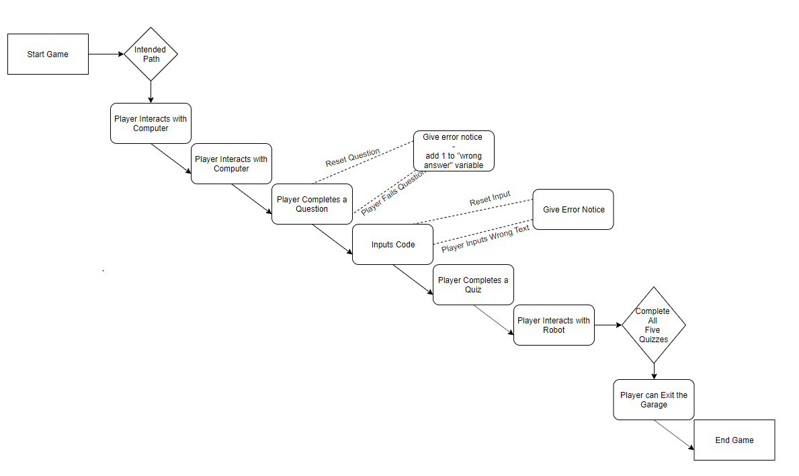

Figure – Intended path to follow in game.

### Main Menu Designs

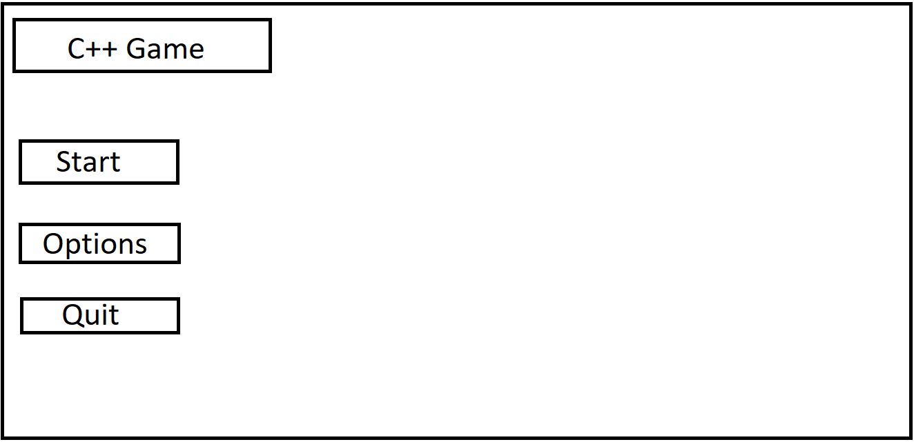

Figure - Initial Menu Layout

### Top Down Design

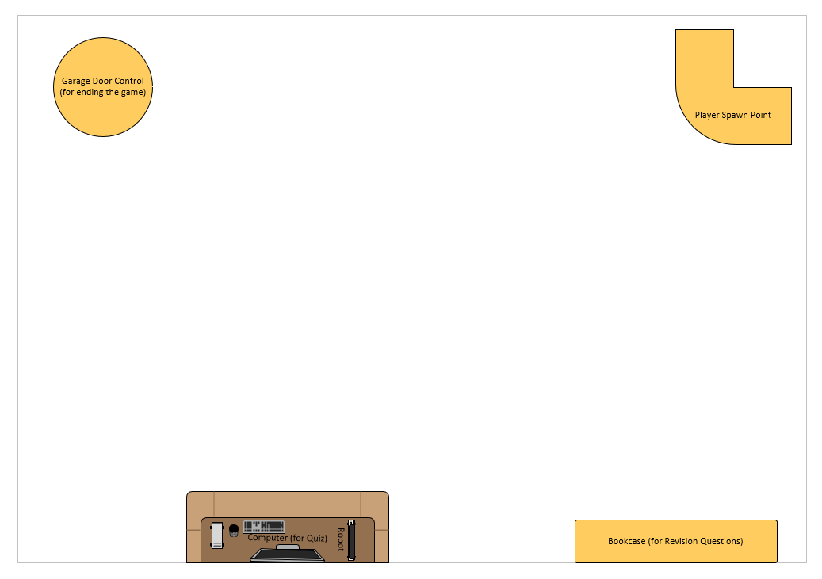

Figure - Basic Room Layout

# Implementation

## Game Overview

### Narrative Changes from Design Segment

The year is 2039. Robots have become easily programmable, with the setup being as mundane as using a combination of C++ knowledge and multiple-choice questions.

You are John, an assumptive scientist, working in an outdoor lab in an unspecified desert. Your job is to program the robot and assess it for public consumption.

### Narrative Overview

When the game is loaded for the first time, the player/John is given a prompt to interact with the computer, which is located on the table near the lab door. By interacting with it, they are introduced to the secondary character, Ceeplus+, an intelligent terminal that is able to speak to the player/John. Their main task is to help the player/John program his robot, located to the left-hand side of the computer, via the completion of a multiple choice-based quiz system, that will send the code into the robot for the player to interact with. Upon completing the various quizzes, the player/John will be able to leave the garage and complete the game.

## Software Specifications

### Software

|  |  |  |
| --- | --- | --- |
| **Software Name** | **Software Version** | **Uses in Project** |
| Unity | 2018.3.14f | Main development environment for the game, used for all scenes. |
| Blender | 2.8 | Used to create the room the game takes place in. |
| Microsoft Word | 2019 | Used to create the text document to present our work. |
| Microsoft Visio | 2019 | Utilized for the top down design in the design segment. |

## Controls

### Player Movement

|  |  |
| --- | --- |
| **Input** | **Action** |
| W | Move Forward |
| A | Move Left |
| S | Move Backwards |
| D | Move Right |
| E | Interact with Object |
| P | Bring Up/Put Away Pause Menu |

### Multiple Choice

|  |  |
| --- | --- |
| Input | Action |
| Mouse Click | Chooses Dialogue Option |
| Esc Button | Closes the Dialogue Menu |

## Game Progression Breakdown

|  |  |  |  |
| --- | --- | --- | --- |
| Quest | Steps | Quiz Completion Reward | Quest Progression |
| Interact with the Computer | 1. Find the computer. | N/A (No quiz completion required) | Unlocks “H3110_W0R1D” |
| HE110_W0R1D | 1. Complete the “Loops” Quiz.  2. Input the code.  3. Check on the robot | Unlocks the “speak” function on the robot. | Unlocks “Basic Function” |
| Basic Function | 1. Complete the “Basic Functions” Quiz.  2. Input the code.  3. Check on the robot | Unlocks the “joke” function on the robot. | Unlocks “Looper” |
| Looper | 1. Complete the “Loops” Quiz.  2. Input the code.  3. Check on the robot | Unlocks the “dance” function on the robot. | “Unlocks Three Argument” |
| Three Argument | 1. Complete the “Function Arguments” Quiz.  2. Input the code.  3. Check on the robot | Unlocks the “customize” function on the robot. | Unlocks “Final Test” |
| Final Test | 1. Complete the “Final Test” Quiz.  2. Input the code.  3. Check on the robot | Unlocks the “wander” function on the robot. | Unlocks “End the Game” |
| End the Game | 1. Open the Garage Door.  2. Walk outside. | N/A (No quiz completion required) | Finishes the game (point of no return) |

## Content Integration

To create our quiz system, we utilized the Dialogue System for Unity (created by Pixel Crushers). For the implementation of the quiz structure, each node was created from scratch, resulting in over 150 different nodes (which included pass and fail states for each question)

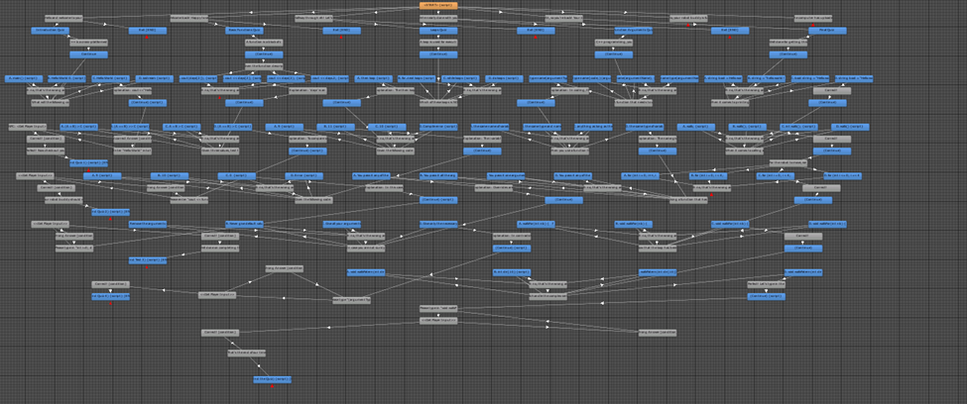

Figure - Flowchart for the Quiz, showing off the 150 different states found inside of the quiz.

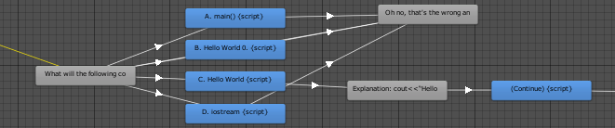

Figure - Progression of Quiz: the player is given four different options (three incorrect and one correct). When the player chooses the correct answer, they will be able to continue with the quiz. Any incorrect answers are counted.

## Code/Scripts

### Main Menu Scripts

#### MainMenuController.cs

|  |
| --- |
| using System.Collections;  using System.Collections.Generic;  using UnityEngine;  using UnityEngine.SceneManagement;  public class MainMenuController : MonoBehaviour  {  Animator anim;  public string newGameSceneName;  public int quickSaveSlotID;    [Header("Options Panel")]  public GameObject MainOptionsPanel;  public GameObject StartGameOptionsPanel;  public GameObject ControlsPanel;  public GameObject LoadGamePanel;  // Use this for initialization  void Start()  {  anim = GetComponent<Animator>();  //new key  PlayerPrefs.SetInt("quickSaveSlot", quickSaveSlotID);  }  #region Open Different panels  public void openOptions()  {  //enable respective panel  MainOptionsPanel.SetActive(true);  StartGameOptionsPanel.SetActive(false);  //play anim for opening main options panel  anim.Play("buttonTweenAnims_on");  //play click sfx  playClickSound();  //enable BLUR  Camera.main.GetComponent<Animator>().Play("BlurOn");  }  public void openStartGameOptions()  {  //enable respective panel  MainOptionsPanel.SetActive(false);  StartGameOptionsPanel.SetActive(true);  //play anim for opening main options panel  anim.Play("buttonTweenAnims_on");  //play click sfx  playClickSound();    //enable BLUR  // Camera.main.GetComponent<Animator>().Play("BlurOn");  }  public void openOptions_Game()  {  //enable respective panel    ControlsPanel.SetActive(false);  LoadGamePanel.SetActive(false);  //play anim for opening game options panel  anim.Play("OptTweenAnim_on");  //play click sfx  playClickSound();  }  public void openOptions_Controls()  {  //enable respective panel    ControlsPanel.SetActive(true);  LoadGamePanel.SetActive(false);  //play anim for opening game options panel  anim.Play("OptTweenAnim_on");  //play click sfx  playClickSound();  }  public void openOptions_Gfx()  {  //enable respective panel    ControlsPanel.SetActive(false);  LoadGamePanel.SetActive(false);  //play anim for opening game options panel  anim.Play("OptTweenAnim_on");  //play click sfx  playClickSound();  }  public void openContinue_Load()  {  //enable respective panel    ControlsPanel.SetActive(false);  LoadGamePanel.SetActive(true);  //play anim for opening game options panel  anim.Play("OptTweenAnim_on");  //play click sfx  playClickSound();  }  public void newGame()  {  if (!string.IsNullOrEmpty(newGameSceneName))  SceneManager.LoadScene(newGameSceneName);    }  #endregion  #region Back Buttons  public void back_options()  {  //simply play anim for CLOSING main options panel  anim.Play("buttonTweenAnims_off");  //disable BLUR  // Camera.main.GetComponent<Animator>().Play("BlurOff");  //play click sfx  playClickSound();  }  public void back_options_panels()  {  //simply play anim for CLOSING main options panel  anim.Play("OptTweenAnim_off");  //play click sfx  playClickSound();  }  public void Quit()  {  Application.Quit();  }  #endregion  #region Sounds  public void playHoverClip()  {  }  void playClickSound()  {  }  #endregion  } |

#### MainMenuSceneTransition.cs

|  |
| --- |
| using System.Collections;  using System.Collections.Generic;  using UnityEngine;  using UnityEngine.SceneManagement;  public class MainMenuSceneTransition : MonoBehaviour  {  // Start is called before the first frame update  void Start()  {    }  // Update is called once per frame  void Update()  {    }  public void ResetLevel()  {  SceneManager.LoadScene(SceneManager.GetActiveScene().buildIndex + 1);  }  public void DestroyGameObject()  {  Destroy(gameObject);  }  } |

### Options Scripts

#### Fullscreen.cs

|  |
| --- |
| using System.Collections;  using System.Collections.Generic;  using UnityEngine;  public class fullscreen : MonoBehaviour  {  // Start is called before the first frame update  void Start()  {  }  public void Fullscreen()  {  // Toggle fullscreen  Screen.fullScreen = !Screen.fullScreen;  }  public void Windowed()  {  // Toggle fullscreen  Screen.fullScreen = Screen.fullScreen;  }  } |

#### SetMusivVol.cs

|  |
| --- |
| using System.Collections;  using System.Collections.Generic;  using UnityEngine;  using UnityEngine.Audio;  using UnityEngine.UI;  public class SetMusivVol : MonoBehaviour  {  public AudioMixer mixer;  public Slider slider;  void Start()  {  slider.value = PlayerPrefs.GetFloat("MusicVolume", 0.75f);  }  public void SetLevel()  {  float sliderValue = slider.value;  mixer.SetFloat("MusicVol", Mathf.Log10(sliderValue) * 20);  PlayerPrefs.SetFloat("MusicVolume", sliderValue);  }  } |

#### VolumeControl.cs

|  |
| --- |
| using UnityEngine;  public class volumecontrol : MonoBehaviour  {  // Reference to Audio Source component  private AudioSource audioSrc;  // Music volume variable that will be modified  // by dragging slider knob  private float musicVolume = 1f;  // Use this for initialization  void Start()  {  // Assign Audio Source component to control it  audioSrc = GetComponent<AudioSource>();  }  // Update is called once per frame  void Update()  {  // Setting volume option of Audio Source to be equal to musicVolume  audioSrc.volume = musicVolume;  }  // Method that is called by slider game object  // This method takes vol value passed by slider  // and sets it as musicValue  public void SetVolume(float vol)  {  musicVolume = vol;  }  } |

## Functionality

### Main Menu

The main menu will consist of three different states;

1. Start – this will bring the player to three further options;
   1. New Game – this will start the game instantly, creating a new, fresh play state.
   2. Back – brings the player back to the original menu options, to allow them to change course.
2. Options – gives the player the option to change and view various objects in the game. These include;
   1. Music – using a toggle bar, the player can manipulate the volume of the music played in game.
   2. Sound - using a toggle bar, the player can manipulate the volume of the sounds played in game.
   3. Fullscreen Toggle – allows the player to change the size of the screen from window view to fully covering the screen.
   4. View Controls – players can view the controls in a separate panel, that are broken down into player movement and the quiz controls.
3. Quit – quits the application instantly, allowing the player to exit.

### Main Game

The main game scene will consist of the following functionality;

**Fully Playable 3D Character**

The player will control John, who is viewed in the third person perspective. While controlling John, the player will be able to do the following;

* 1. Movement – the ability to move in four different states;
     1. Forward
     2. Left
     3. Backward
     4. Right
  2. Interaction – John can interact with different objects found in the level (which will be detailed further in the list)

**Interactable Objects**

**Note: Each interactable object will have a floating red arrow above them. This is to help players recognize the different interactions. Players will also be notified by a prompt located in the top of the screen.**

* 1. Bookcase – the basis for revision in the game, there are multiple options for the player to choose regarding the C++ topic (which will help with the quizzes found on the computer). Each topic will have a light amount of knowledge and consist of;
     1. Introduction – offers information on cout (used to display messages)
     2. Basic Functions – offers information on Arrays and Boolean Operator functions.
     3. Loops – offers information on different Loop Types, executing a Loop and Printing a Loop.
     4. Function Arguments – offers information on declaring functions, passing of functions, function overrides and the value of a function.
  2. Robot – this is the robot the player will be programming via the quizzes. After the player has completed a quiz, they will unlock new functionalities. These are;
     1. Speak – after the player has finished the first quiz, the robot can be commanded to say one of two phrases;
        1. Hello World - says “Hello World” in a robotic Scottish voice.
        2. Goodbye – says “Goodbye” in a robotic Scottish voice.
     2. Jokes – after the player has finished the second quiz, the robot can say a joke with either a witty or sarcastic tone.
     3. Dance – after the player has finished the third quiz, they will be able to make the robot dance to a song. These options are;
        1. YMCA – inspired by the classic song, the robot will do the traditional dance while said song plays in the background. The song is turned off when the player leaves the option.
        2. Breakdance – the
     4. Customize - once the player has completed the fourth quiz they will acquire the ability to customize the robot with three different styles;
        1. Default – the normal state the robot appears in.
        2. Black Paint – covers the robot completely in black paint.
        3. Glass Material – the robot will change from a solid color to a glass aesthetic
     5. Upload – the final function the player can unlock the ability for the robot to upload it’s consciousness to the cloud.
  3. Computer – used for the quiz (see section below)
  4. Door Control – when the player has finished all five quizzes and has full functionality of the robot, they will be able to access the control for the door. Doing so will trigger a cutscene showing the player can leave.

1. Pause Menu – Allows the player to pause the game, while also giving different options;
2. Quest Log – shows any quests the player is currently completing or have completed already. There is a maximum of seven different quests for the player to complete in our game, which are;
   * 1. Interact with the Computer
     2. HE110_W0R1D
     3. Basic Function
     4. Looper
     5. Three Argument
     6. Final Test
     7. End the Game
3. Return to Main Menu – Returns the player back to the main menu (discussed earlier).

**Quiz**

The main component of the game, the multiple-choice system is accessed via the computer. The questions/topics found inside the quiz are the same as the questions found inside the design portion (see page 9). However, each quiz has an added function added during the development phase, that allows the player to input code via an input box;

1. Quiz 1. Enter "Hello World" into the terminal:
2. Quiz 2. Please enter "functions[3];" below. Doing so will give the robot some new functionality!
3. Quiz 3. Please type in "int i=0; do{'i=10'i endl;}" below. This will update the robot to allow for looped movement!
4. Quiz 4. Please type "(argumentType argumentName){code;}"
5. Quiz 5. Please type in "void walkPatern(int dir[10])"

**\*videos showcasing the functionality talked about above can be found in the YouTube video playlist.**

## Showreel (Screenshots)

### Main Menu

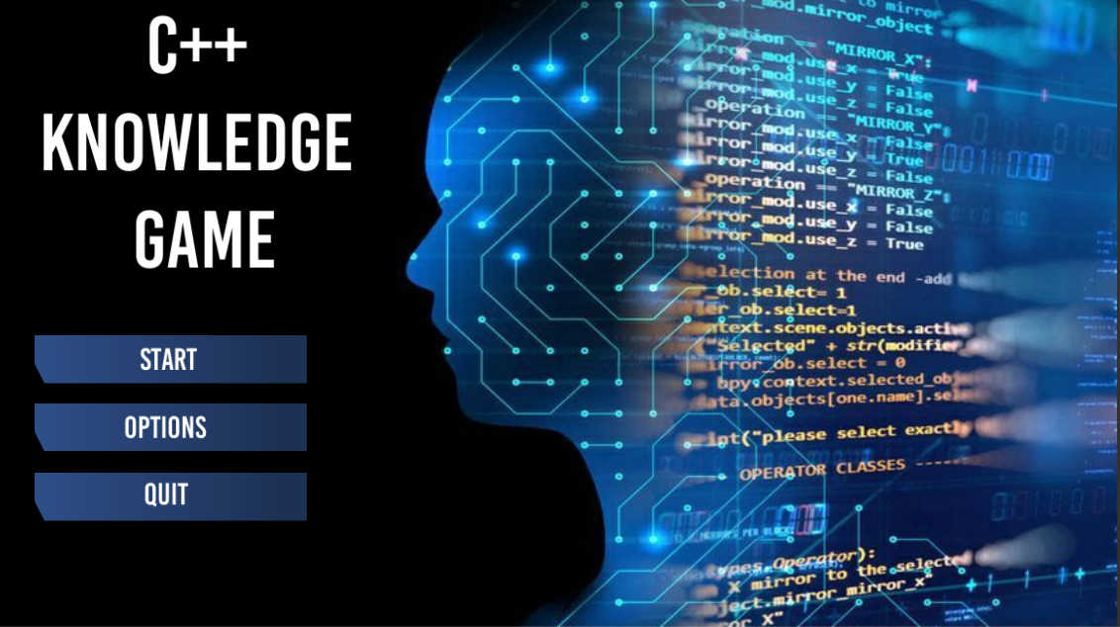

Figure - Game Main Menu (Initial Screen) with three options (start the game, change the options and to quit the game entirely)

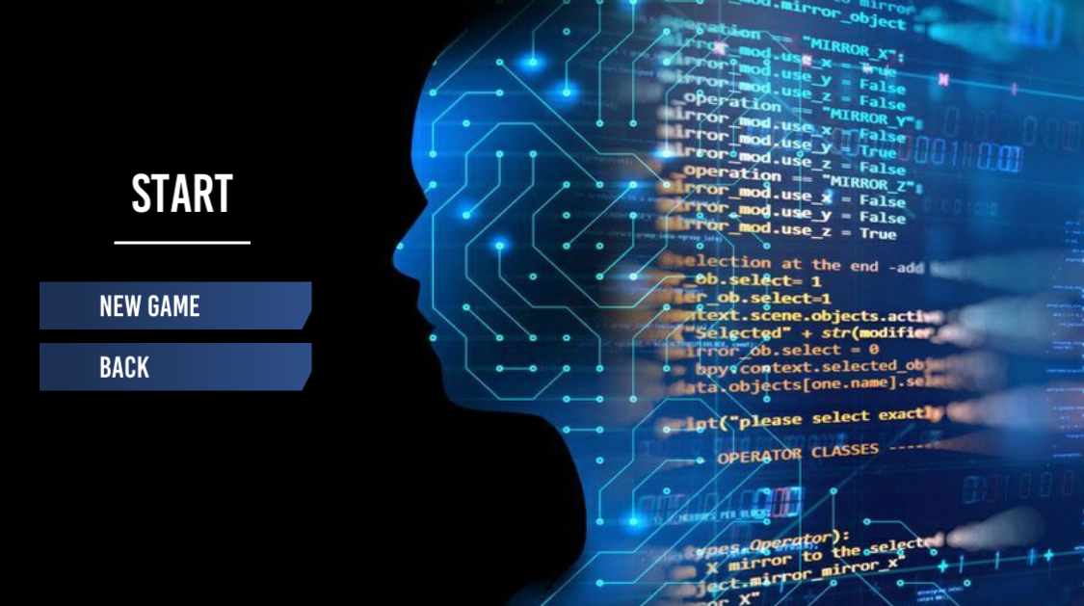

Figure - Start Options: Allows for New Game and a Back Button (bringing the player back to the original menu screen)

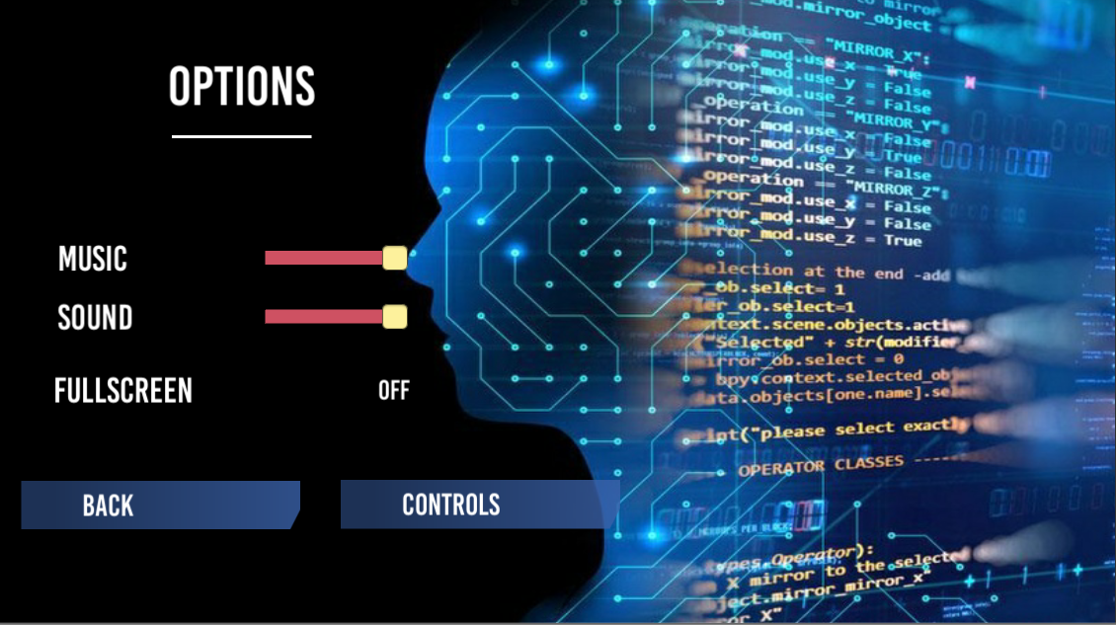

Figure - Options Menu, which allows the user to change the audio levels (such as Music and Sound), toggle full screen and check the controls (detailed below)

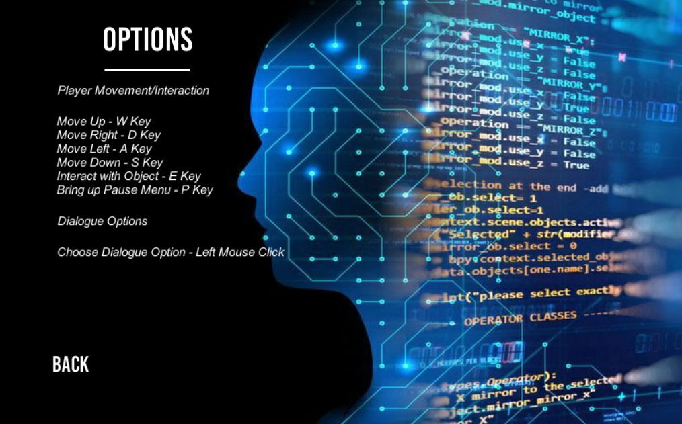

Figure - Control Showcase

### Introduction Slides

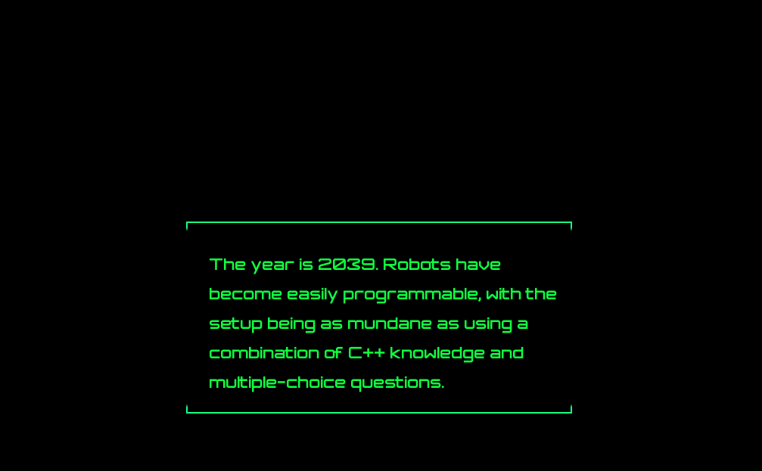

Figure - Introduction Slide #1 (gives background to the game)

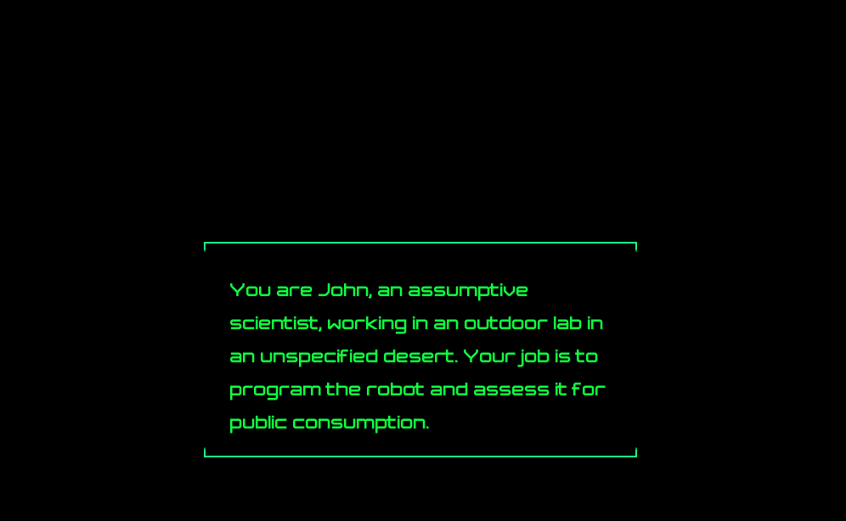

Figure - Introduction Slide #2 (Gives the player a name/background)

### Main Game

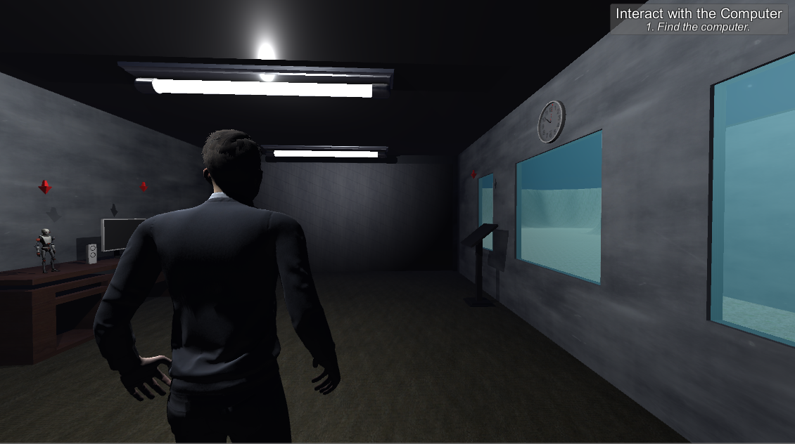

Figure - Player's default positioning after starting the game (note the quest system located at the top right hand corner of the screen)

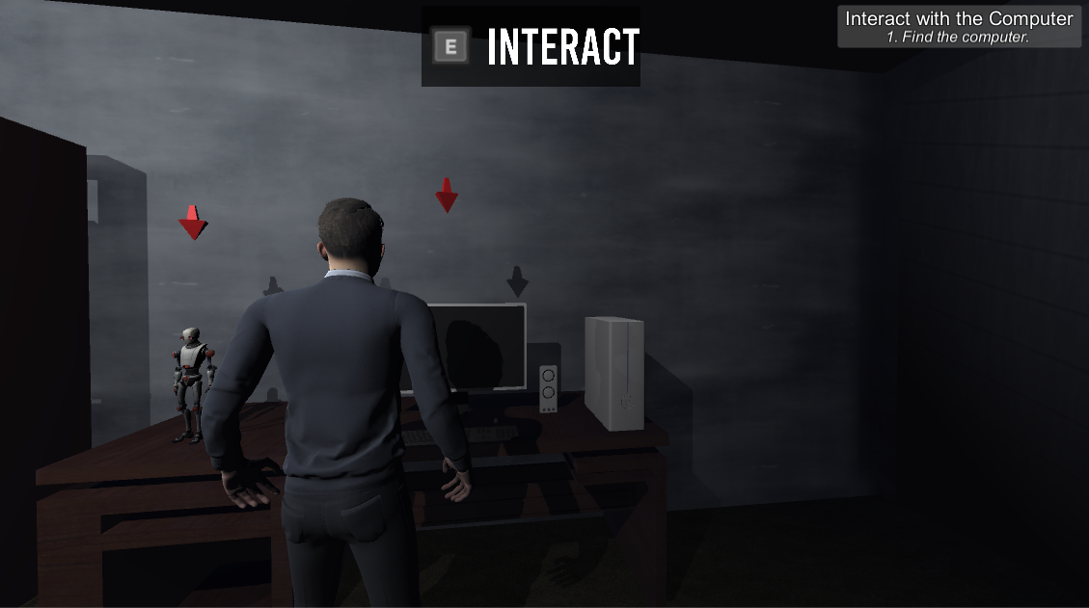

Figure – Interaction prompt that notifies the player they are near an interactable object

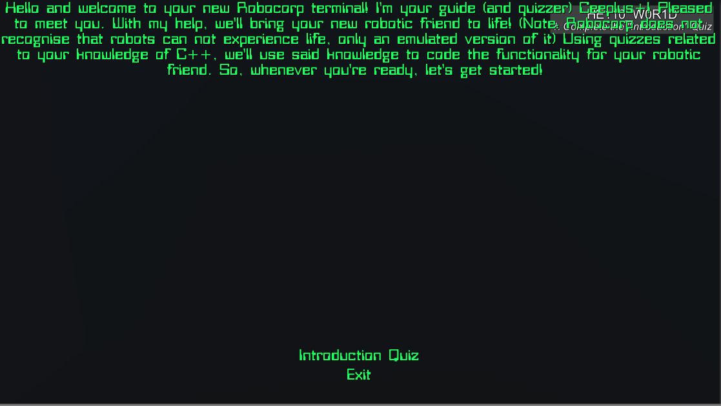

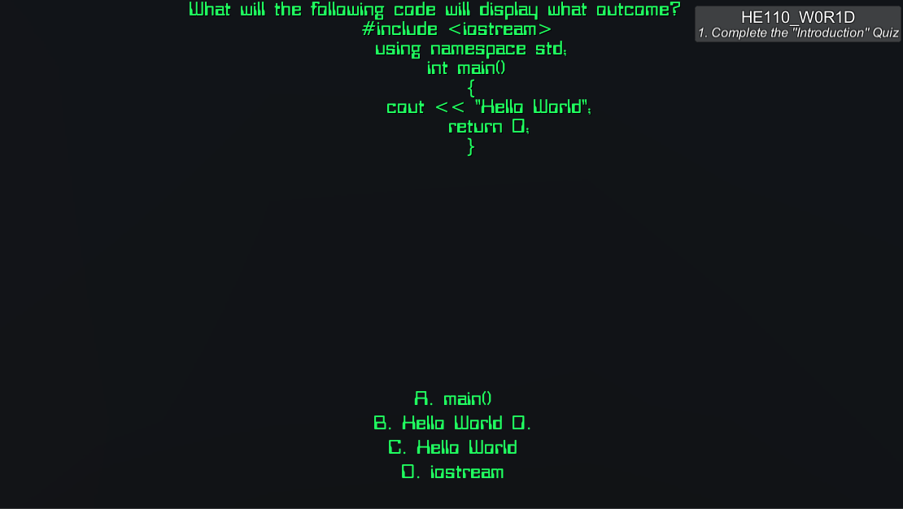Figure – Example of the dialogue found inside of the game. In this capture, the player is interacting with the terminal

Figure – Example of the Multiple-Choice Quiz. The question here is from the first quiz, Introduction

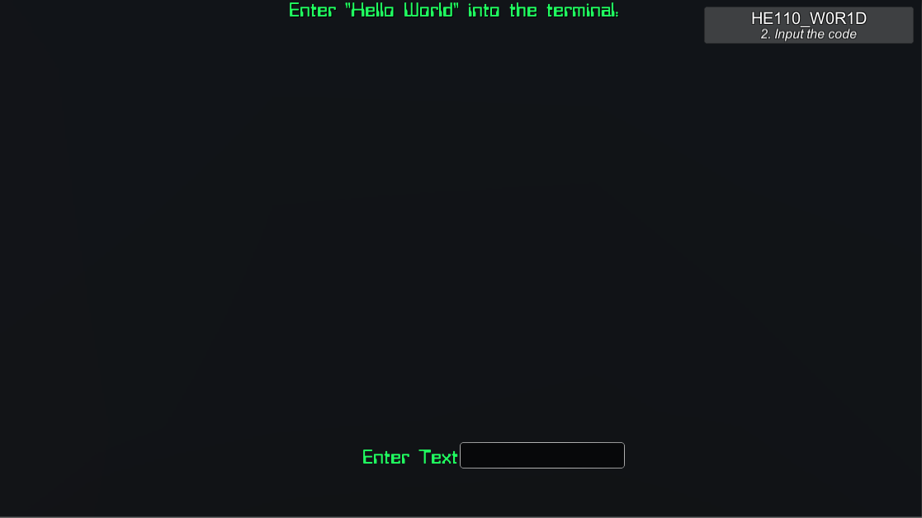

Figure – Example of inputting the code text. This is the input found at the end of quiz 1

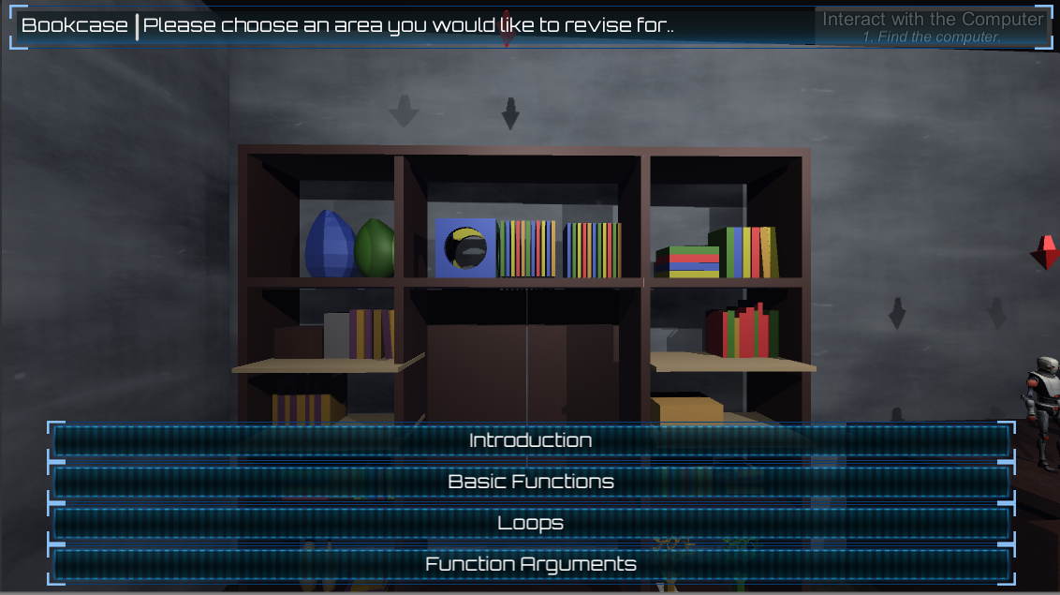

Figure – Example of the Bookshelf interaction, here the player is choosing what topic to revise for

### Credits

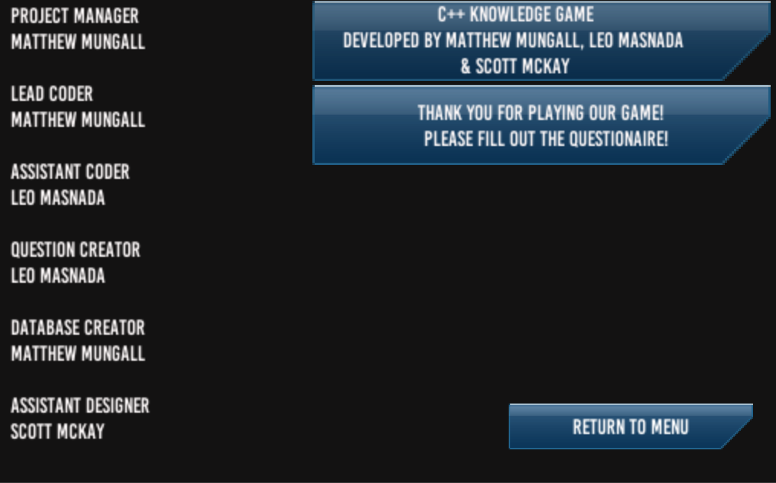

Figure - Credits the player receives at the end of the game (shows the player who performed which roles in the overall development of the game)

### Book Shelf Dialogue Tree

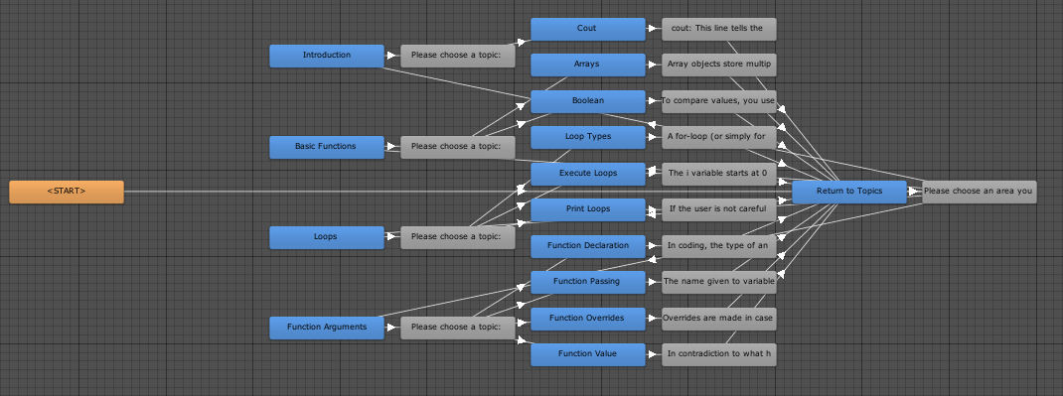

Figure - Flowchart for the Bookshelf, showing off the 31 different states

### Robot Dialogue Tree

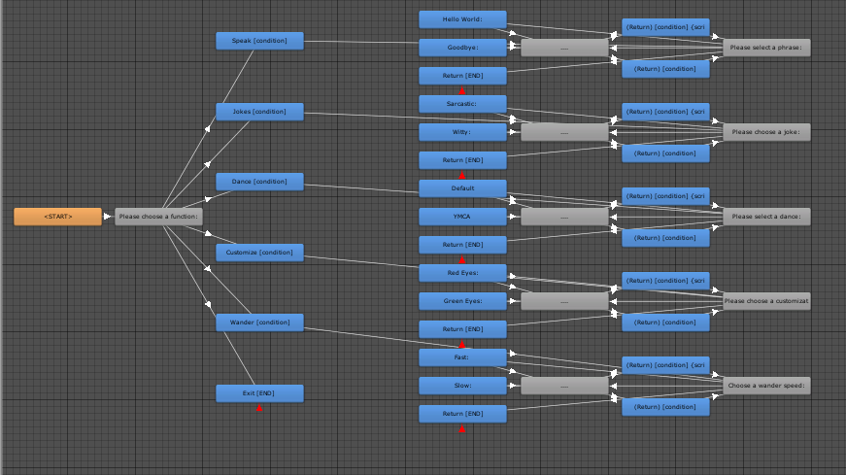

Figure - Flowchart for the Robot, showing off 41 different states

### Garage Door

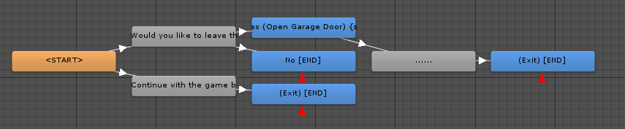

Figure - Flowchart for the Garage Door, showing off 7 different states

### Grade

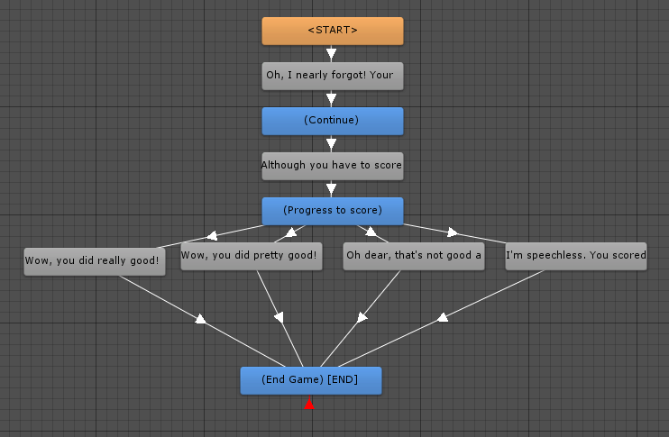

Figure - Flowchart for the Grade system, which has 9 different states

### Introduction Dialogue

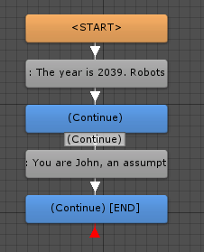

Figure - Flowchart for the introduction, which has 4 different states

### Dialogue Database Variables

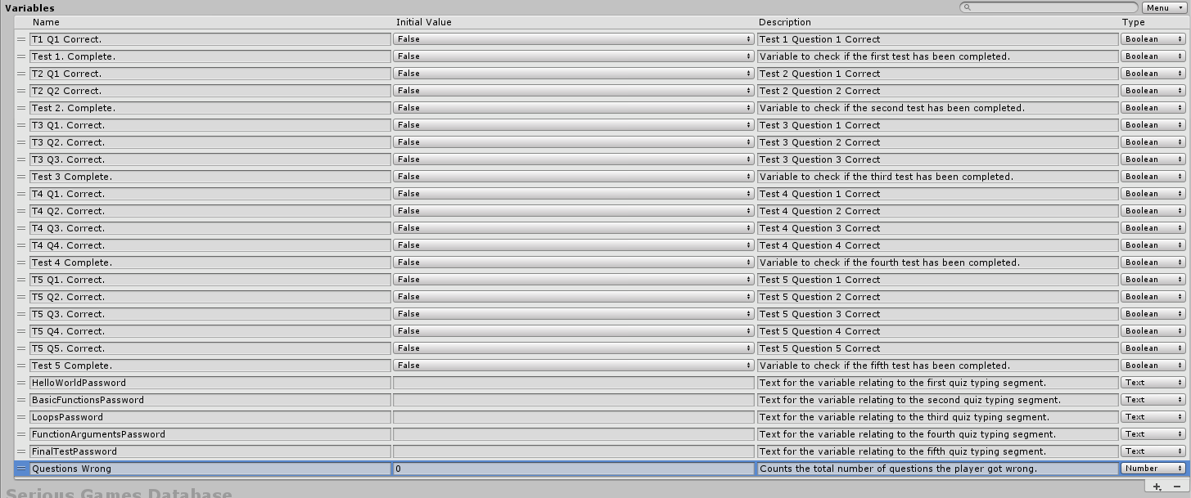

Figure - List of variables counted in the Dialogue System

### Quest List

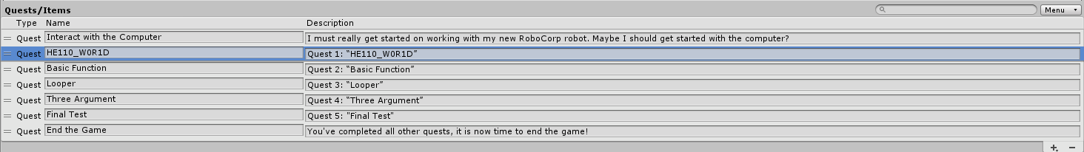

Figure - All quests featured in the game

### Quest Layout

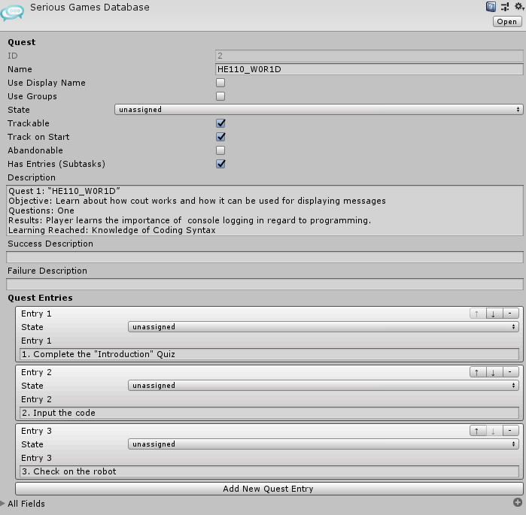

Figure - Typical quest layout: displays the description, different side tasks and it's state.

## Video Walkthrough

For a playlist relating to all recorded material, it can be found here at;

<https://www.youtube.com/playlist?list=PLHFkl798yQEgNl-FlkXTbw6VD3GoGQ-YT>

The video provides a walkthrough on the game.

## Version Control

To access the project in its entirety, use the following GitHub link: <https://github.com/matthewmungall96/SeriousGamesRepo>

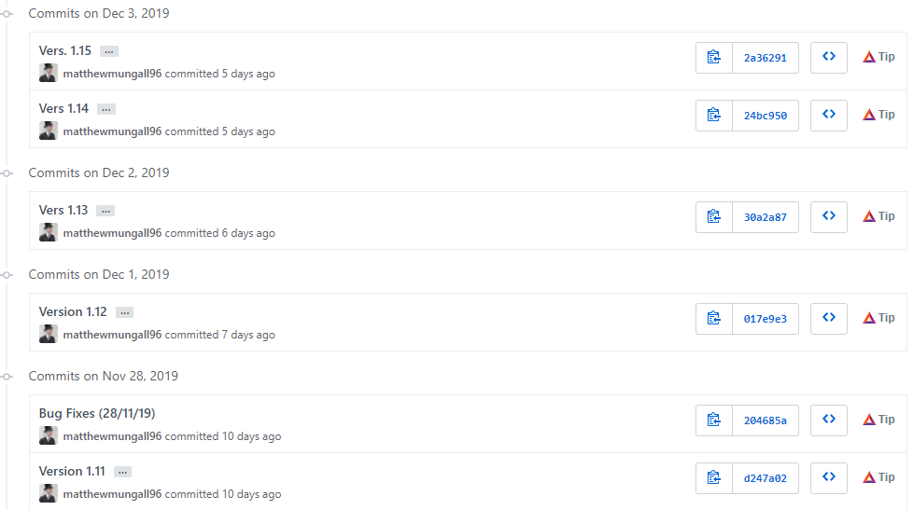

Figure - Version Control in GitHub using iterative numbering for new versions

# Evaluation

## Evaluation Methodology

The methodology that is used to evaluate the quality of the game and the quality of the teaching provided by the game will be as follow:

The Players will be provided a list of instructions along with the game, telling them why the game has been made, what kind of public it is aimed at and what kind of knowledge it teaches. They will then be asked to complete the game and give feedback upon what they did, understood and felt through the game through the media of a questionnaire that has been prepared beforehand.

Through this questionnaire, the Player will be able to give some information about if (or if not) the game seemed accessible as described before, if it was an enjoyable form of teaching for the set topic and if they feel curious enough after playing the game to dig further and research more about the taught topic on their own.

## Experimental Design

In order to evaluate the teaching capabilities, the experimental phase has been divided into a series of steps and the process has been passed down to the experimental groups.

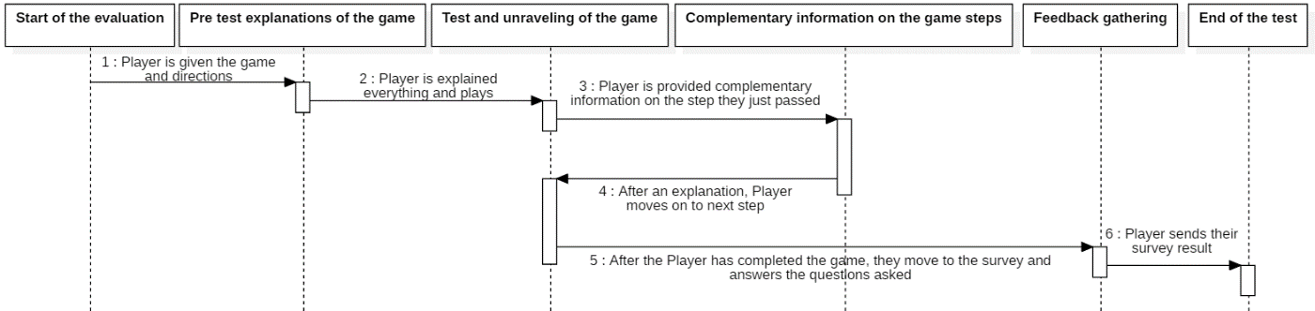

Figure - Experimental Design Diagram

A simple and one lined process that will keep the Player in a simple situation after which they will be required to take a step back and evaluate their appreciation of the game they have been presented.

In addition to what the game has to offer through the logic questions, some additional information is provided in order to consolidate what each question will have given the player an occasion to think of with as extensible goal to pike their curiosity and have them try to learn more on their own later on.

## Questionnaire Template

### Design of Questionnaire

|  |  |  |
| --- | --- | --- |
| Intended Question | Context | Answer Format |
| Do you have any background knowledge on coding? | Participants will provide any background knowledge they may have, and if it is relevant to the topic found in the game. | Text Box  Text being limited to 50-100 words. |
| Did you enjoy the game? | Participants will be asked if they enjoyed the game. This will be used to gauge how well they received the experience. | Multiple Choice (1-5)  With 1 being very unenjoyable, and 5 being very enjoyable. |
| Do you feel more confident in coding? | Asked to see if the participant had any beneficial experience gained from playing. Will be one of the important results from the process. | Multiple Choice (1-5)  With 1 being very unconfident, and 5 being very confident. |
| Do you feel the game has met these learning outcomes?   1. Coding Syntax 2. Coding Efficiency 3. Code Reusability 4. Understanding of Code 5. Practical coding for problem solving | A series of mini questions, covering the intended learning outcomes discussed previously in the document. This will be the second important question. | Text (10 lines with 100 characters per line)  Each learning outcome will be discussed, allowing for the participant to give their thoughts on each. |
| Did you find the subject matter interesting? | Gauges how interesting the participant found the subject. | Multiple Choice (1-5)  With 1 being very uninteresting, and 5 being very interesting. |
| Are you interested in learning how to code following the game exercise? | Checks to see if the participant has become invested in some way regarding the subject matter. | Multiple Choice (1-5)  With 1 being very uninterested, and 5 being very interested. |
| Were you able to understand the topic matter showcased in the game? | Checks to see if the participant has any understanding of the subject they have just been tested on. | Yes/No Field |
| Finally, do you feel like this game would be well received in a learning environment? (such as a school or secondary education?) | The most important question, this will gauge whether the participant genuinely believes this game could be used as a good teaching tool. | Number Box (1-5)  With 1 being not appropriate, and 5 being very appropriate. |

### Implementation of Questionnaire

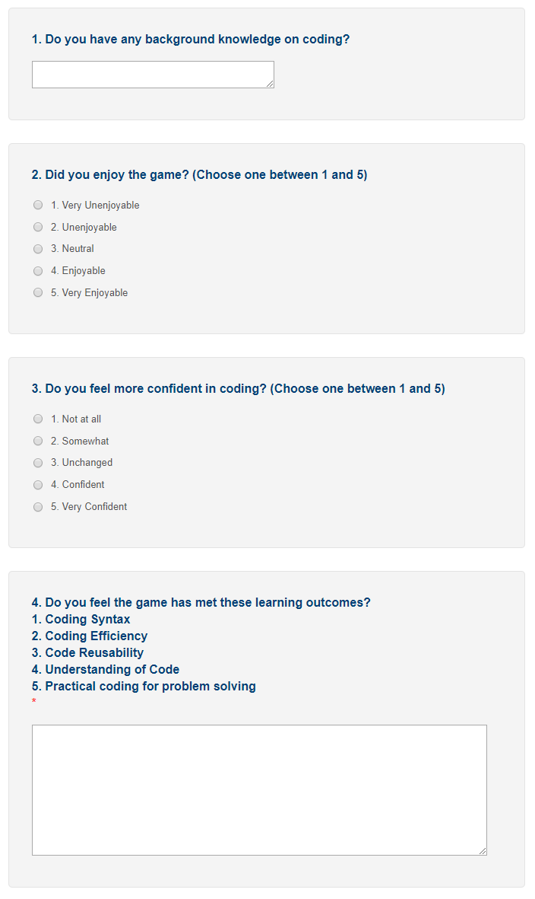

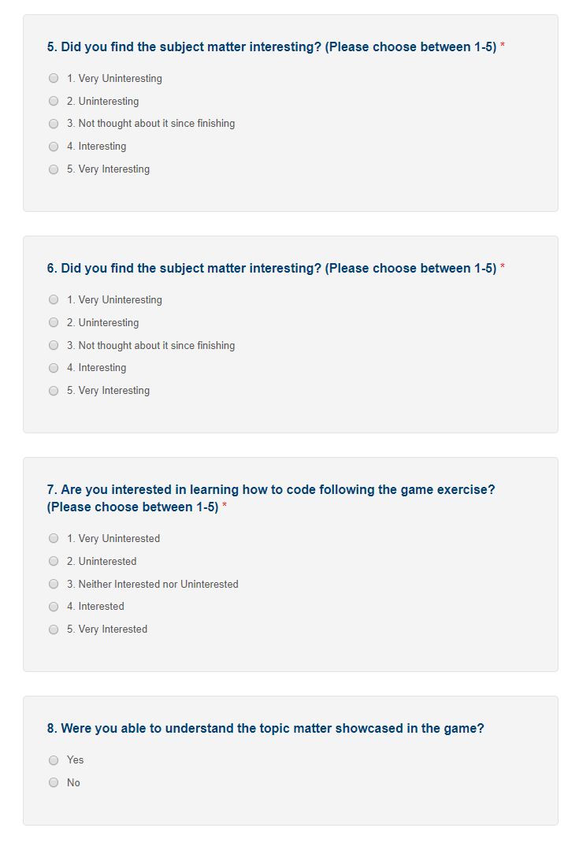

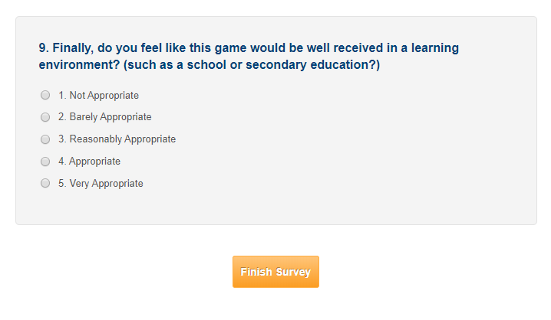

Link to the survey - <https://www.smartsurvey.co.uk/s/4VBZ0/>

## Identification of Participants

There will be three different groups of participants (each group consisting of ten members) being evaluated, which will include;

* Colleagues – these participants will be recruited via the UWS Lanarkshire Computer Game Design Class.
* Friends & Family – Recruited by speaking to any of the team member’s friends or family.
* Outside Sources – using the internet, we will recruit potential candidates via different social platforms (such as Discord, Facebook etc.)

## Feedback Analysis

Thanks to the survey that will be provided with the game, each Player will be given the opportunity to provide their own judgment on the different elements of the game and assert if the Serious Game they have been given possess usability, meaning that the Player will be able to tell if the Serious Game has been helpful to them or not in order to learn something new or consolidate an already owned knowledge of the topic.

The Player, through the survey, will also both reference the likeability and accessibility of the game; if the game was not correctly advertised or that the format doesn’t fit the topic presented, the Player will be able to show it through their votes.

As a last thing that the results of the survey will demonstrate, the game’s aptitude to teach someone through the media of a video game better or not than a more traditional media of teaching like an actual class. Through this point, the Player will be able to tell if, or not, the game has been made with an intent of teaching that was relevant in their opinion and if they appreciated the form of a serious game to learn what the game had to teach them.

## Weaknesses of Evaluation

As the game will be provided to various types of participants, not all of them will be able to be monitored while performing the tests, therefore not everyone will possess the same possibilities and information they need.

The format of a questionnaire also is an impersonal way to do things, the reactions while going through the game and the time after being done may differ. Taking a step back on something may as well make the Player come up with a different answer than what they would have said on a specific question once the whole game has passed.

Lastly, the limitations of a questionnaire with multiple choices restrains the vast possibilities of answers that the Player could come up with and limits the feedback they will “officially” provide through the questionnaire, making any form of actual feedback restrained to things passed directly to the development team, making it then some sort of unusable data if the process of evaluation is restrained to what the questionnaire will provide.